

**18CSE361T Web Programming**

**Register Number : RA2011031010044**

**Name of the Student: RIYA SINGH**

|  |  |
| --- | --- |
| **Semester / Year** | **: Vth / IIIrd** |
| **Department** | **: CSE** |
| **Specialization** | **:** INFORMATION TECHNOLOGY |



***SRM INSTITUTE OF SCIENCE AND TECHNOLOGY***

S.R.M. NAGAR, KATTANKULATHUR -603 203

**BONAFIDE CERTIFICATE**

**Register No.**

*Certified to be the bonafide record of work done by*

*RIYA SINGH of* CSE

*IT , B. Tech Degree course in the Practical* **18CSE361T**

**Web Programming** *in SRM Institute of Science and Technology, Kattankulathur during the academic year 2022-2023(Odd Sem)***.**

**Signature of the Faculty Signature of the HOD/NWC**

|  |  |
| --- | --- |
| Submitted for University Examination held on | SRM Institute of Science and |
| Technology, Kattankulathur. |  |
| **Examiner-1** | **Examiner-2** |

**INDEX: -**

|  |  |
| --- | --- |
| Abstract | pg-4 |
| Introduction | pg-5 |
| Requirements | pg-5 |
| Technologies used | pg-5 |
| Codes | Pg-6 to pg-10 |
| Snapshot of the output & Conclusion | pg-11 |

**ABSTRACT:-**

# Portfolio management (PfM) is a critically important discipline, which organizations must embrace in order to extract the maximum value from their project investments. Essentially, PfM can be defined as the translation of strategy and organizational objectives into projects, programs, and operations (portfolio components); the allocation of resources to portfolio components according to organizational priorities; alignment of components to one or more organizational objectives; and the management and control of these components in order to achieve organizational objectives and benefits.

Introduction: -

A portfolio is typically a showcase of the most impressing work you’ve done in a specific niche whether it is creating art, taking photos, making designs, developing websites, or even writing content. You basically show your best work in a portfolio.

In a similar manner, a portfolio website is a platform where you showcase this talent. This enables your prospects to see your skills (better known as samples) so that they can decide if they should hire you or not.

So basically, your probability of getting hired depends majorly on this and the best thing is that it is all in your hands. You are the one who will be making the portfolio and only you can decide if it is good enough to get you some bucks or not.

These are some common traits of a portfolio website:

First off, it’s not a technique or a method. Rather, it is just a way to display your content in a pictorial form.

They usually do not contain loads of text and focus mainly on attractive visuals.

A portfolio website usually has several grid elements that consist of a number of images. They are usually organized in a way that the user gets a great experience while using the website.

**Requirements: -**

VS Code

XAMPP

**ľechnologies used: -**

* HTML
* CSS
* JAVASCRIPT

CODE:

HTML:

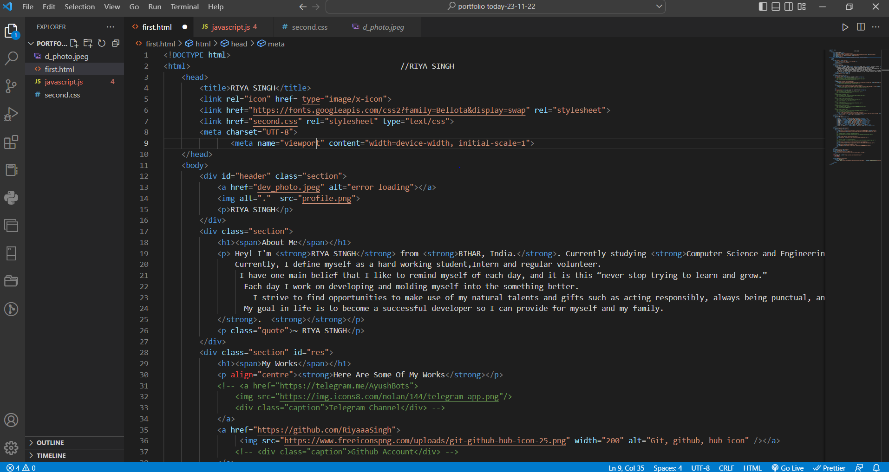

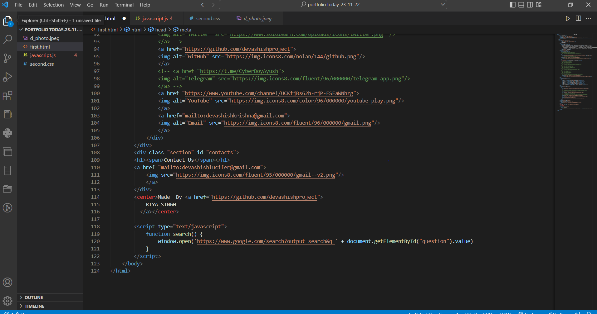

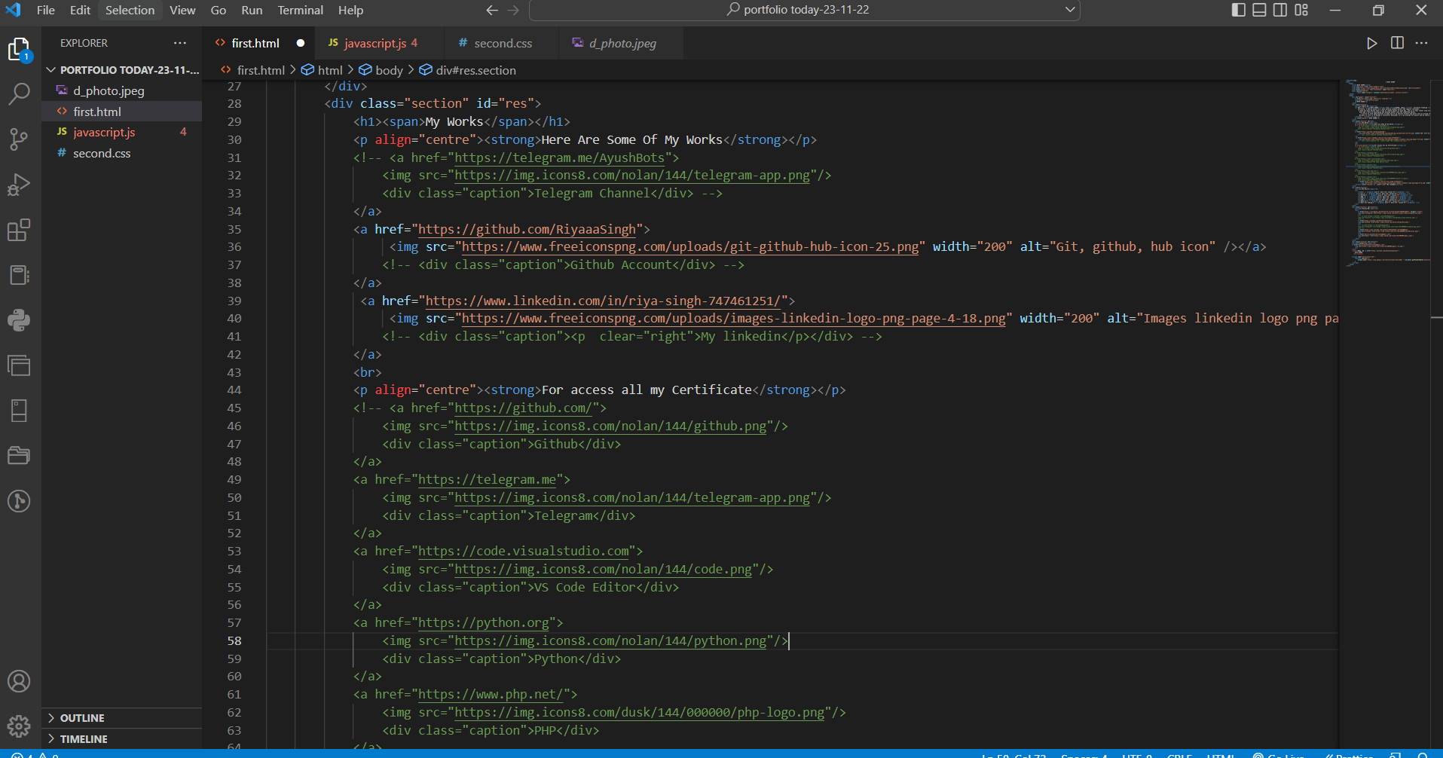

# JAVASCRIPT:

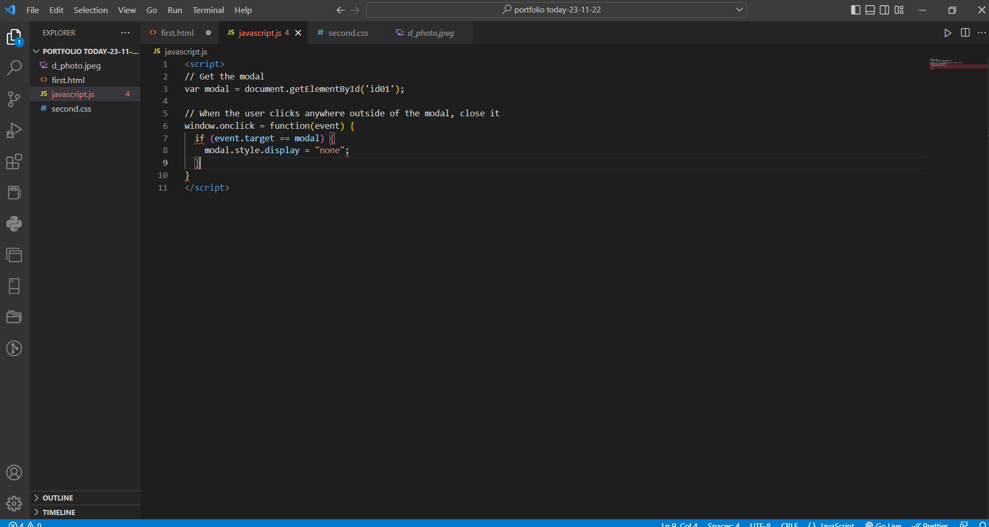

CSS:

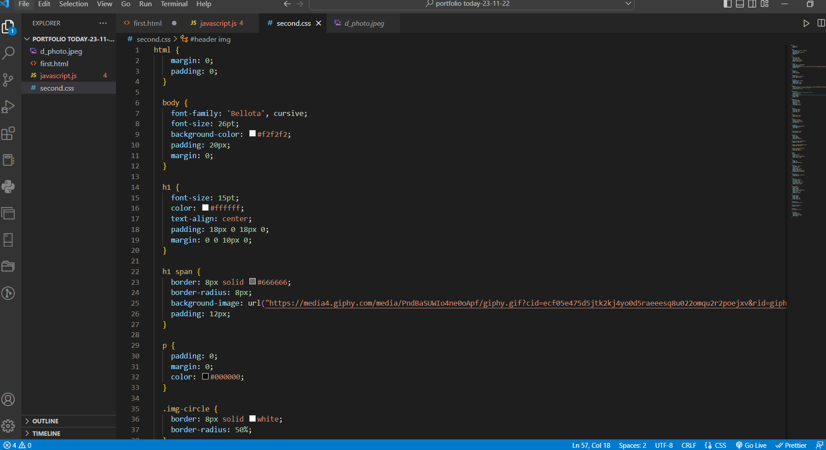

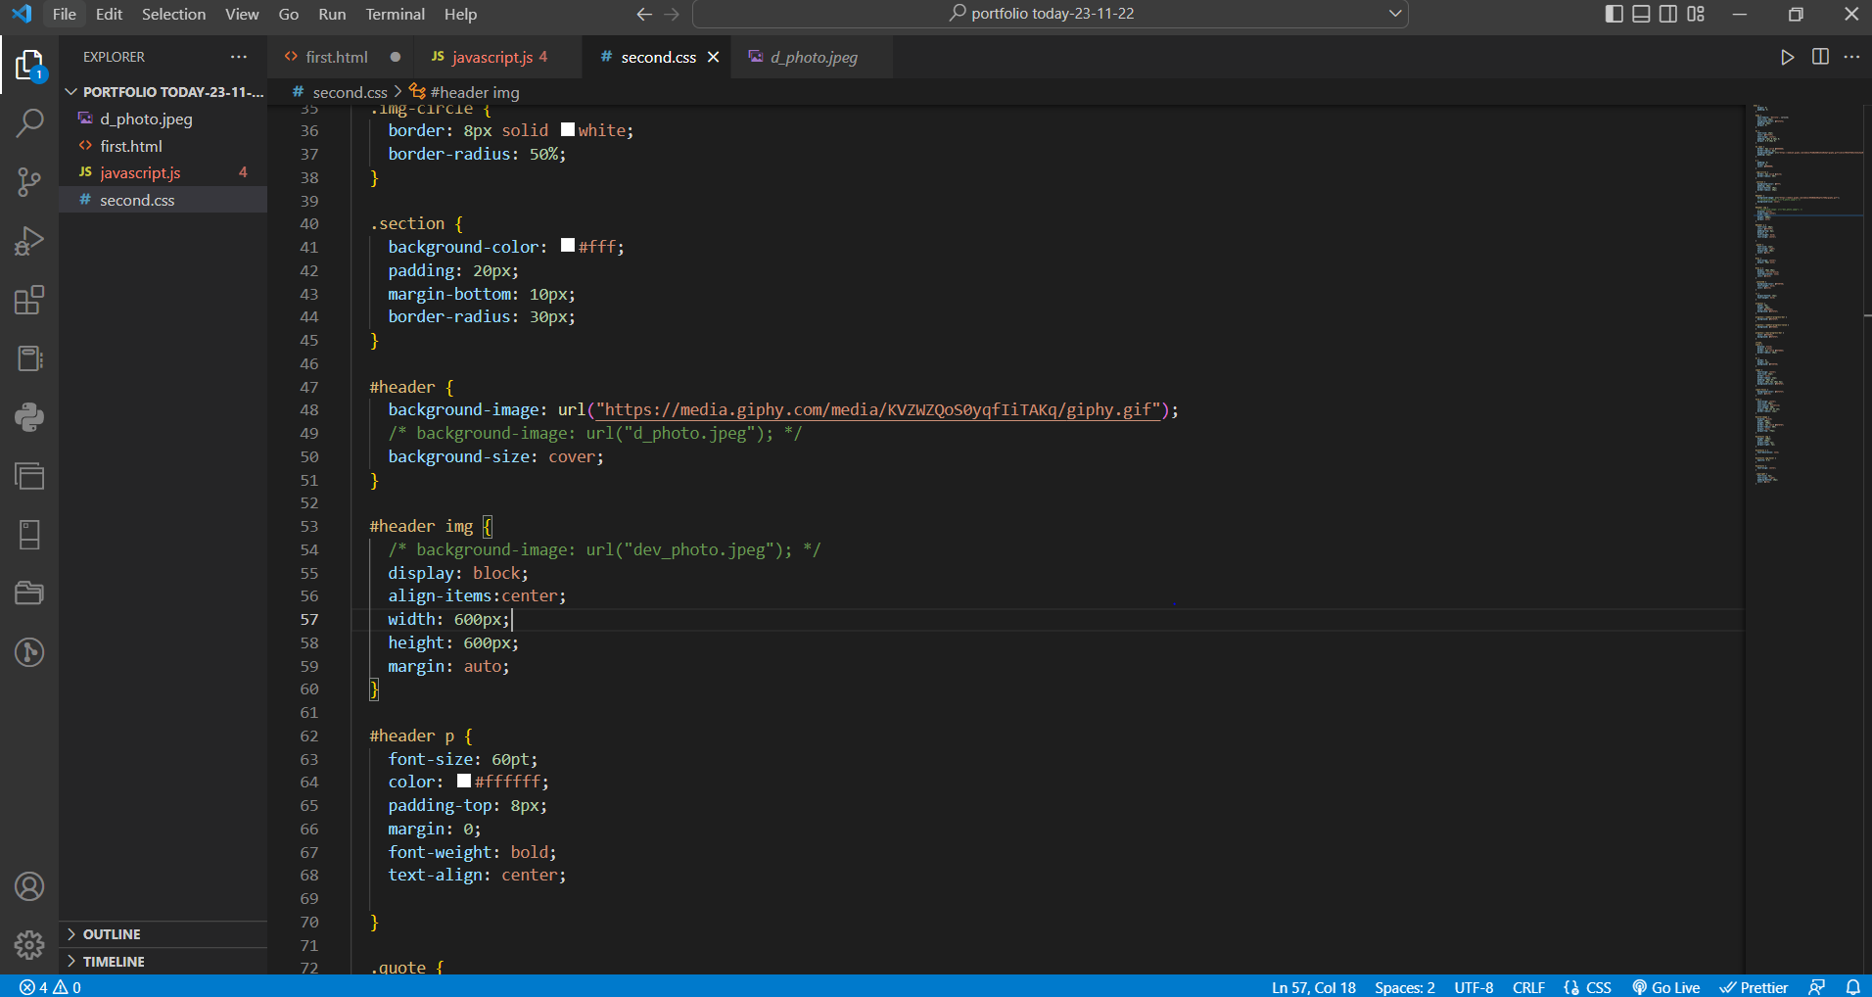

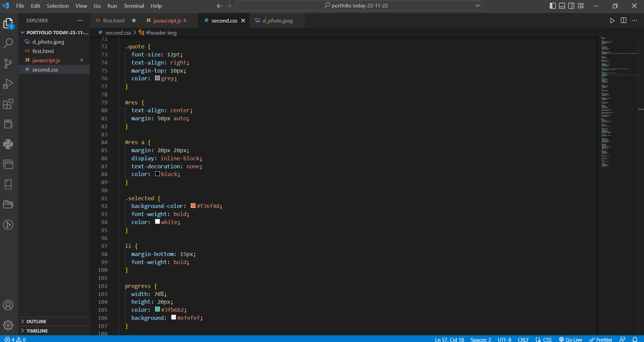

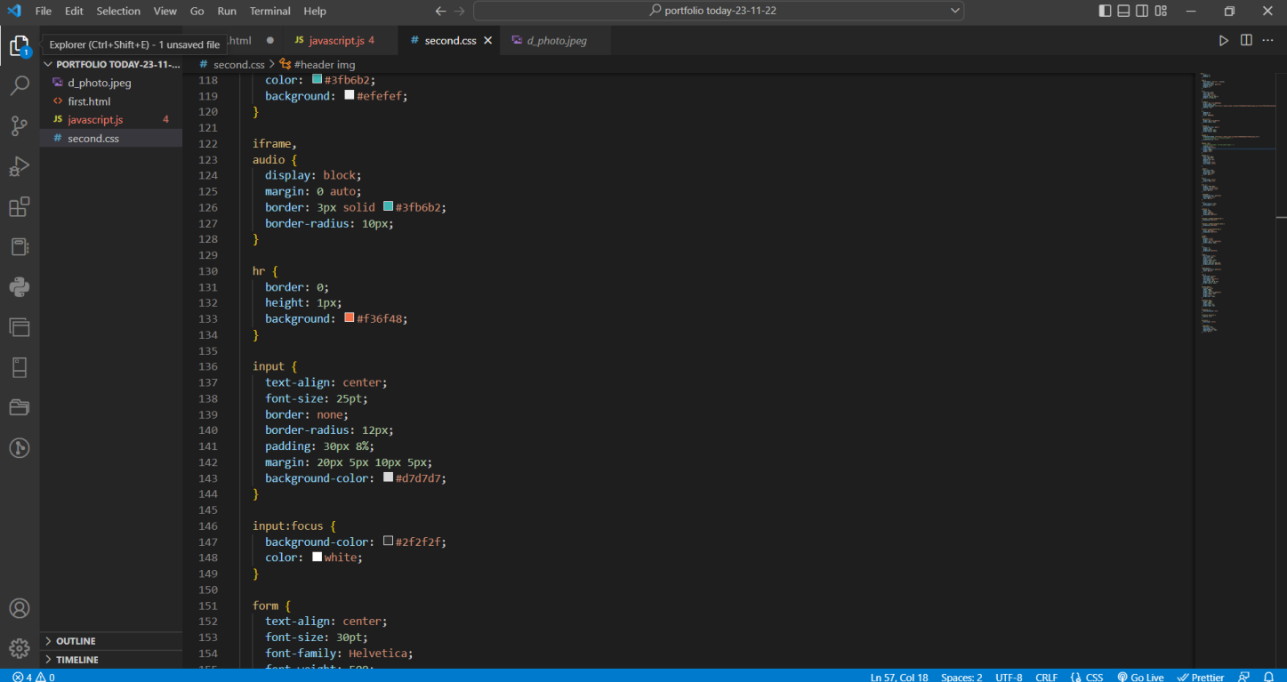

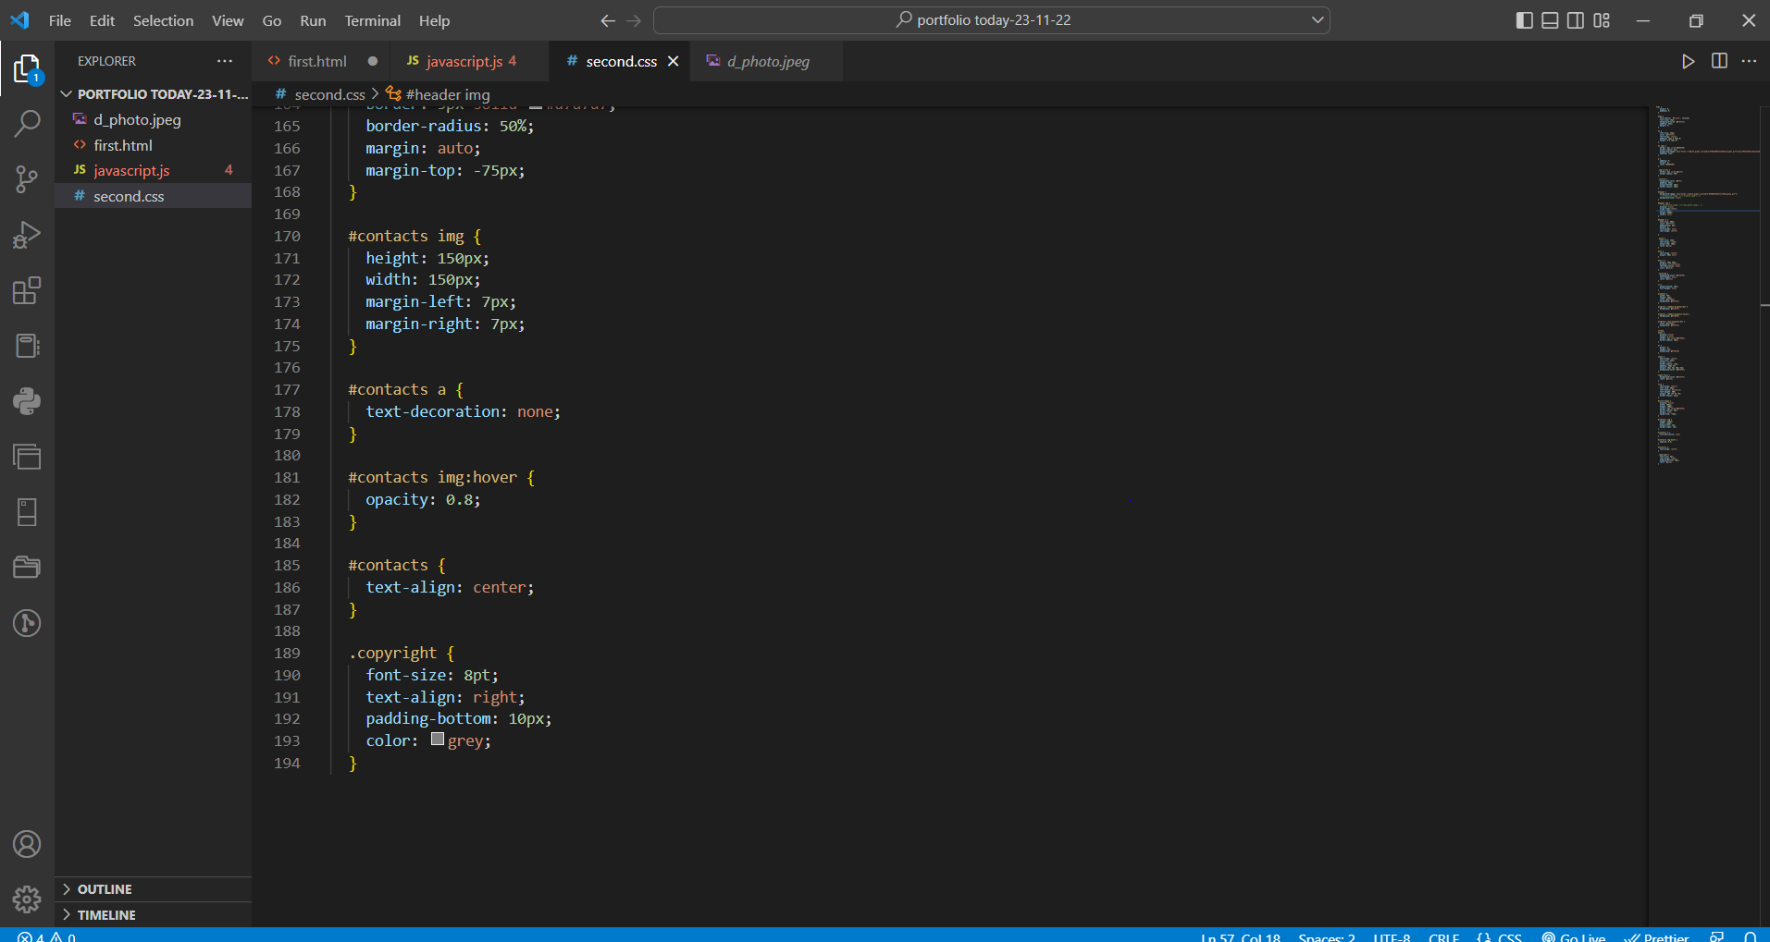

**Snapshot of the project: -**



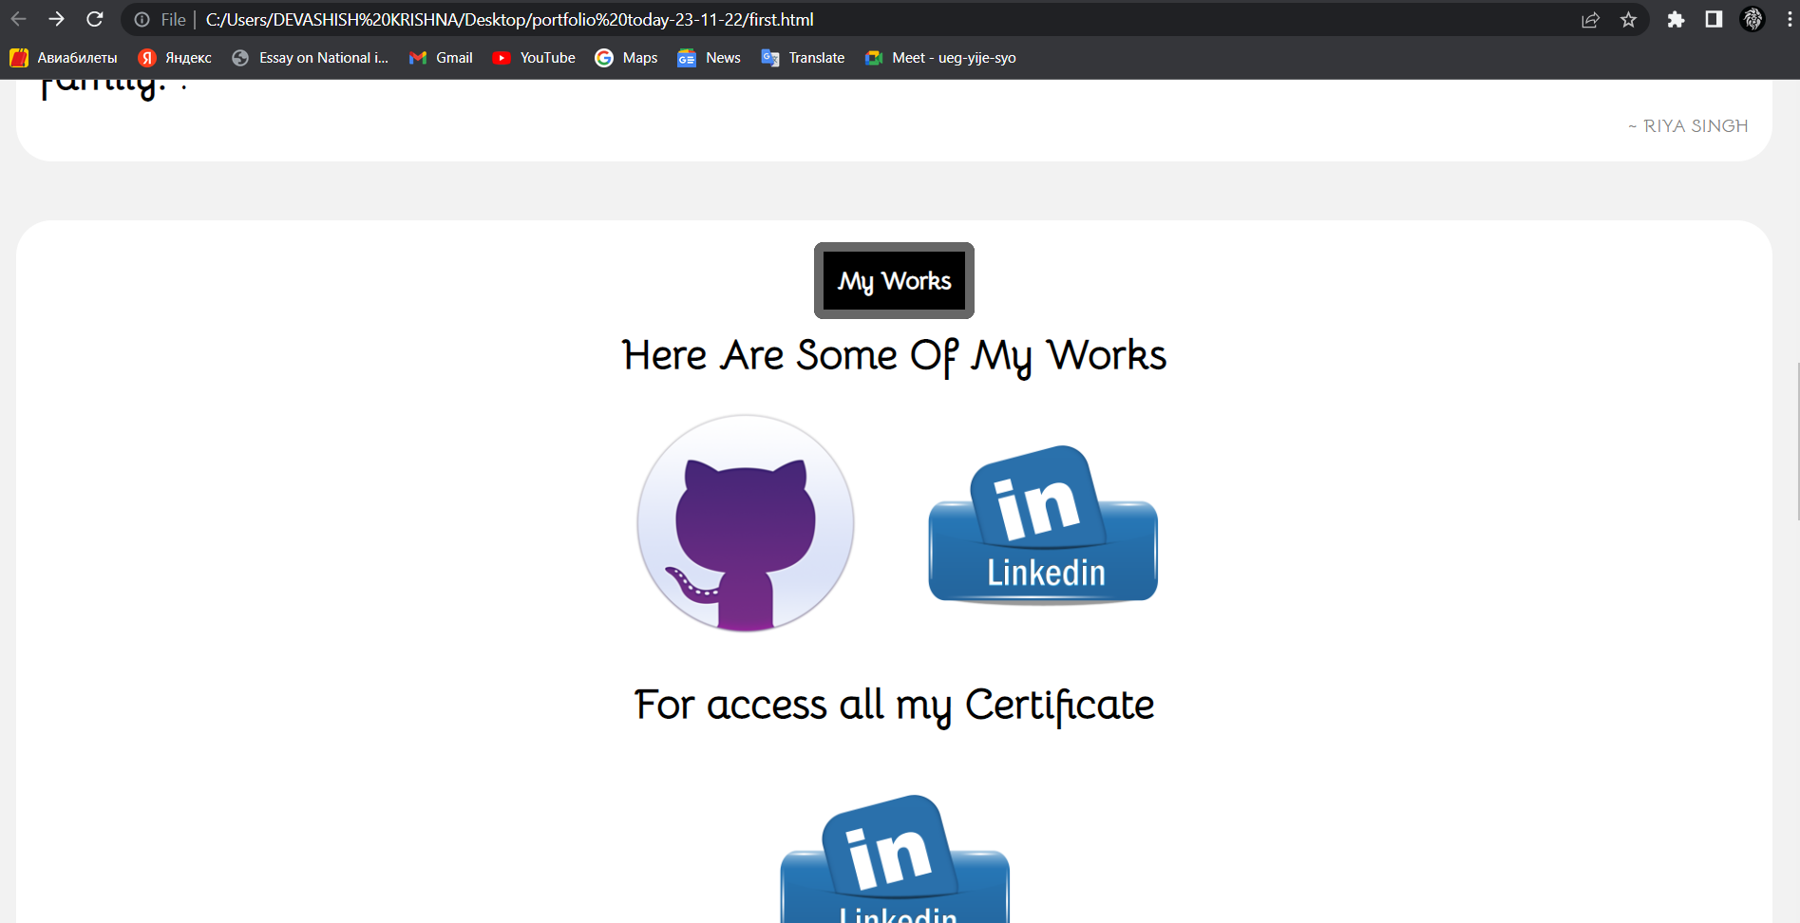

**Conclusion: -**

The Portfolio was implemented successfully and the outputs were recorded.